Flow Phenomena in Renal Arteries with Partial Coverage after Aneurysm
Dhurjati Chakrabarti,ª Laura D. Edwards^{b}
^{a,b*}Chemical Engineering, The University of the West Indies, St. Augustine, Trinidad and Tobago
laura.edwards@sta.uwi.edu
Abstract
Since endovascular aortic repair (EVAR) has a lower death rate and a shorter recovery period, it is being used more often to treat abdominal aortic aneurysms (AAA). Renal artery coverage complications, however, continued to be a serious worry. The flow pattern, wall shear stress distribution, and blood perfusion during a cardiac cycle were all numerically investigated here using three different renal orientations and three different partial renal coverage degrees. According to the findings, the renal artery with a downward orientation experienced more blood perfusion and less unfavourable wall shear stress (WSS) distribution at the mild partial coverage. Notably, the renal artery exhibiting a horizontal orientation experienced a more unfavourable distribution of WSS. All of the renal arteries showed highly disturbed wall shear distribution in terms of severe coverage (approximately 45–50 %), which significantly reduced blood perfusion. It's interesting to note that the artery oriented upward experienced a lower rate of blood perfusion reduction. In summary, renal arteries oriented downward may reduce the risk of renal occlusion in cases of mild renal coverage following EVAR, whereas renal arteries oriented horizontally may increase the unfavourable wall shear distribution. However, for serious coverage (>50 %), regardless of renal orientation, there is a significant increase in the risk of renal ischemia.
Keywords: Flow phenomena, hemodynamics, orientation, CFD, renal artery
1. Introduction
Surgeons have generally accepted endovascular aneurysm repair (EVAR) as a treatment for abdominal aortic aneurysms (AAAs) since it was first presented by Parodi et al. in the early 1990s. While EVAR offers some advantages over open AAA surgical repair, including a shorter recovery period and a lower 30-day mortality rate (Paravastu et al., 2014), it has drawbacks. Using a computational fluid dynamics approach, Liu et al. investigated the impact of partial renal coverage on hemodynamics and discovered that partial coverage to the renal branch office causes flow recirculation and vortices with an unfavourable wall shear stress distribution (Edwards et al., 2018) around the renal ostium. As a result, the degree of obstruction increased in the renal arteries' oscillatory shear index (OSI) and relative resistance time (RRT) (Liu et al., 2018). Additionally, in an in vitro study, Van de Velde et al. examined the impact of partial renal coverage on flow patterns and wall shear stress (WSS). They discovered that the proximal cranial wall of the renal artery exhibits low and oscillating WSS, indicating the development of renal artery stenosis and atherosclerosis in the future. It should be mentioned that the study only used
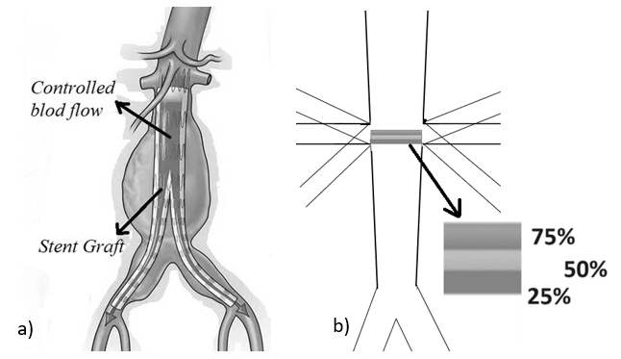

Figure 1 a) abdominal aortic aneurysms (AAAs) and Stent; b) Construction of the idealized abdominal artery (AA) with visceral branches, three typical take-off angles
two-dimensional velocity measurement to identify hemodynamic parameters, despite the fact that the renal arteries' true flow pattern was three-dimensional. The purpose of the present study was to numerically evaluate the effect of partial renal coverage on hemodynamics based on the inﬂuence of renal orientation. This study will help to understand the potential risk of progressive renal disease in relation to renal artery anatomy for EVAR. As indicated by Martínez et al. (2012), the use of simulation will provide better insight into the phenomena. Kerst et al. (2015) noted that the utilisation of CFD provided useful results for observation.
- Methods
Jun Wen et al. (2023) provided the inspiration for this study, which was basically the same simulation and varification. Figure 1a shows AAAs and stent. Figure 1b depicts the construction of the idealized abdominal artery (AA) with visceral branches. The AA portion of the artery extends uniformly from a 24 mm diameter circular cross-section at the descending aorta's inlet to a 17 mm diameter circular cross-section at the AA bifurcation. Renal arteries (RAs) have a diameter of 5 mm. Next, the covered-stent partial renal coverage was constructed and its thickness of 0.2 mm was set based on the postoperative computer tomography angiography (CTA) of a patient whose AAA was repaired by EVAR using infrarenal fixation. Three typical take-off angles, 110 degrees (upward), 90 degrees (horizontal), and 50 degrees (downward) were chosen for analysis to more thoroughly investigate the effect of renal artery take-off angle on renal artery occlusion after EVAR. The blood was thought to be incompressible, homogenous, and non-Newtonian. The following were the matching governing equations:
$ρ\frac{∂\overline{u}}{∂t}+ρ\left(\overline{u}.∇\right)\overline{u}+∇p-μ∆\overline{u}=0$ | (1)
$∇.\overline{u}=0$ | (2)
$\overline{u}$ and $p$ stand for the velocity vector and pressure value, respectively, $ρ$ is the density (1050 kgm⁻³).
The Carreau-Yasuda model in this study describes the dynamic viscosity ($μ$), which can be useful to reflect the relationship between viscosity and shear rate $\dot{γ}$:
$\frac{μ-μ_{∞}}{μ_{o}-μ_{∞}}={[1+{(k\dot{γ)}}^{a}]}^{\frac{n-1}{a}}$ | (3)
Using the values given by Cho and Kensey (1991) as well as Jun Wen et al. (2023), at low shear rates, $μ_{o}$ = 0.056, and at large shear rates, $μ_{∞}$ = 0.0035, the blood flow is observed. 1.9, 0.2, and 1.3 were the values assigned to the material coefficients k, n, and a, respectively. The total shear stress applied to the wall throughout a cardiac cycle can be determined using the time-average WSS (TAWSS) (Jun Wen et al., 2023), which is defined as follows:
$TAWSS=\frac{1}{t}\int_{0}^{t}{\left|WSS\left(s,t\right)\right|dt}$ | (4)
A popular metric for assessing the axial directional shift of WSS during a cardiac cycle is the oscillatory shear index (OSI), which is defined as (Ku et al., 1995). A low OSI value shows unidirectional shear flow, whereas a high OSI value suggests oscillatory shear distribution on the vessel wall during a cardiac cycle. The OSI scale runs from 0 to 0.5.
$OSI=0.5\left[1-\frac{\left|\int_{0}^{t}{WSS\left(s,t\right)dt}\right|}{\int_{0}^{t}{\left|WSS\left(s,t\right)\right|dt}}\right]$ | (5)
Another often used indicator is the relative residence time (RRT), which calculates the length of time the particles spend close to the vessel wall. It falls between 0 and infinity. Regions with low and oscillating WSS are indicated by high RRT (Lee et al., 2009), which is defined as (Himburg et al., 2004):
$RRT=\frac{1}{\left(1-2.OSI\right).TAWSS}$ | (6)
Velocity profile (VP) with shear stress distribution is defined as:
$v=\frac{b^{2}}{2μ}\left[{\left(\frac{y}{b}\right)}^{2}-\frac{y}{b}\right]\frac{d}{dx}(p+ρgh)$ | (7)
$b$ is the distance between Caudal and cranial wall, $μ$ is the fluid viscosity and h is the vertical distance of the flow point from the datum line.
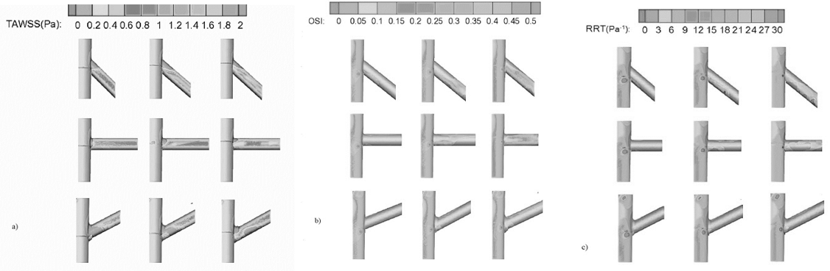
Figure 2: Unsteady WSS fluctuations on the left renal arteries. Three types of renal orientation (downward, horizontal, upward) and three types of partial renal coverage (25%, 50%, 75%) were taken into account. a) TAWSS; b) OSI; c) RRT.

The hemodynamic parameters based on the finite volume approach were visualized and analyzed using commercial computational fluid dynamics software, ANSYS FLUENT. In this investigation, an implicit 3D solver with default segregation was used. To adjust the pressure and velocity, the Semi-Implicit approach for Pressure Linked Equations (SIMPLE) approach was applied. Each pulse cycle in pulsatile simulations was divided into 300 time-steps, each measuring 2.5 ms (the simulated cycle period was T = 0.75 s). For each simulation, four cardiac cycles were chosen in order to get consistent outcomes.
- Results and Discussions
The TAWSS contour map on the left renal arteries is displayed in Figure 2a. Regarding the renal arteries oriented horizontally and downwardly, areas on the cranial and caudal walls exhibit high (>2 Pa) and low (0.4 Pa) TAWSS, respectively. These regions are particularly noticeable near the branch orifice and become more pronounced as coverage deteriorates. Downstream in the renal arteries, the total WSS level progressively dropped, particularly as the partial coverage worsened. It should be mentioned that, in addition to the exacerbation of the partial coverage, there is a negligible decrease in the overall WSS distribution downstream in the renal arteries with an upward inclination.

However, the contour maps of OSI and RRT, which have a similar distribution, are shown in Figures 2 b and c. Regarding the moderate degree of coverage (~25 %), it is rare to find high RRT (>30 Pa⁻¹) and OSI (>0.4) in any renal artery. Concerning the significant level of coverage (less than 50 %), there were evident variations in the OSI and RRT distributions, which were influenced by the distinct orientations. Regarding the downward-oriented renal arteries, the caudal wall near the covered stent or away from the branch orifice is where elevated OSI and RRT are most commonly seen.
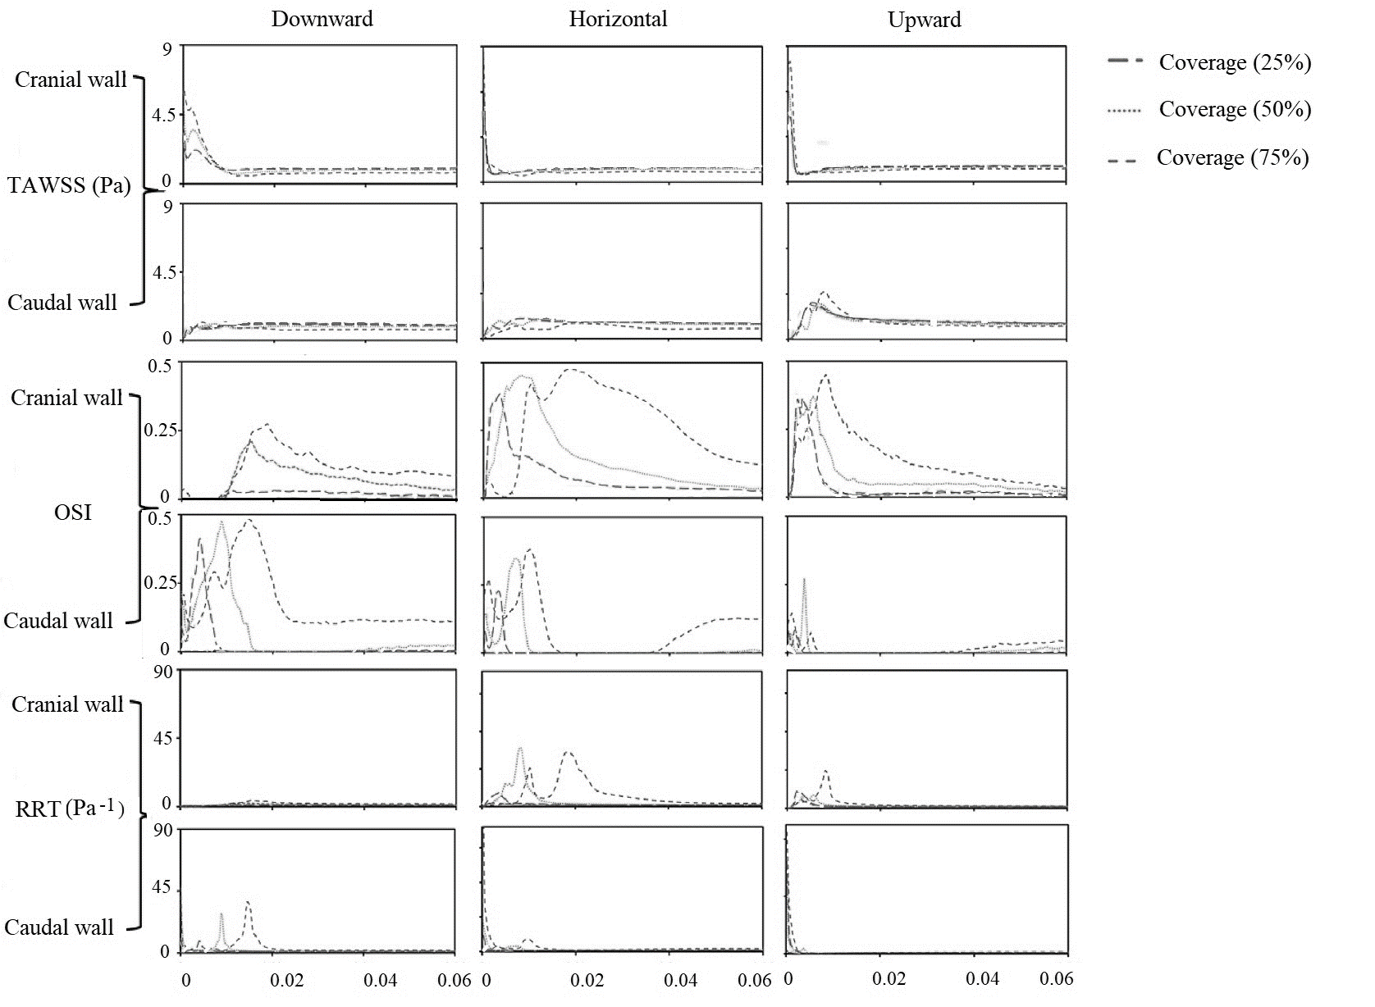
Figure 3: TAWSS, OSI and RRT on left renal artery for renal orientations and degrees of coverage.
Regarding the horizontally oriented renal arteries, high OSI and RRT distribution can be detected in both the caudal wall (near the covered-stent) and cranial wall (far from the branch orifice). Even though the partial coverage of the renal arteries with the upward-oriented artery reached 75 %, there was no discernible high OSI and RRT distribution. As seen in Figure 3, TAWSS, OSI, and RRT were examined along the caudal and cranial walls of left renal arteries. First, because to renal branching and incomplete coverage, high and low TAWSS typically developed near the branch orifice. It is noteworthy that the renal arteries with horizontal orientation on their caudal wall exhibit the highest areas rate of low TAWSS, particularly when the partial coverage reaches 75 %, whereas the arteries oriented upward exhibit the lowest areas rate. Conversely, the cranial wall of the renal arteries oriented horizontally also had the highest WSS value, whereas the arteries oriented downwardly had a comparatively lower WSS in the same area. Regarding the OSI distribution on the renal arteries, it was discovered that the cranial wall of the arteries had the highest OSI, and that the aggravation of partial coverage was correlated with an increase in the average OSI value. OSI distribution can be found on the cranial wall of real arteries with horizontal orientation, even if the coverage was mild (horizontal) with respect to 25 % coverage as for the area-averaged OSI on cranial wall. Regarding the distribution of RRT within the renal arteries.
In general, the renal arteries oriented downward on the cranial wall had the lowest RRT distribution when compared to the other two artery types (downward vs. horizontal and upward) with regard to 25 % coverage. The highest RRT value recorded on the cranial wall was only 3.8 Pa⁻¹ when the partial coverage reached 75 %. But in this area, the renal arteries oriented horizontally distributed. The instantaneous flow rate of left renal arteries with varying orientations and partial coverage levels during a cardiac cycle is depicted in Figure 4. In general, the renal arteries with downward and horizontal orientations did not significantly differ in terms of instantaneous flow rate. Similar reversed flow rates of approximately 4% (downward) versus horizontal occurred in both types of renal arteries during the diastolic phase, when partial coverage reached 75 %.It is surprising, though, that the upward-oriented renal arteries, which may have resulted from the retrograde flow pattern, eliminated the reversed flow during the diastolic period and increased the flow rate during the systolic period with regard to the 75 % partial coverage.
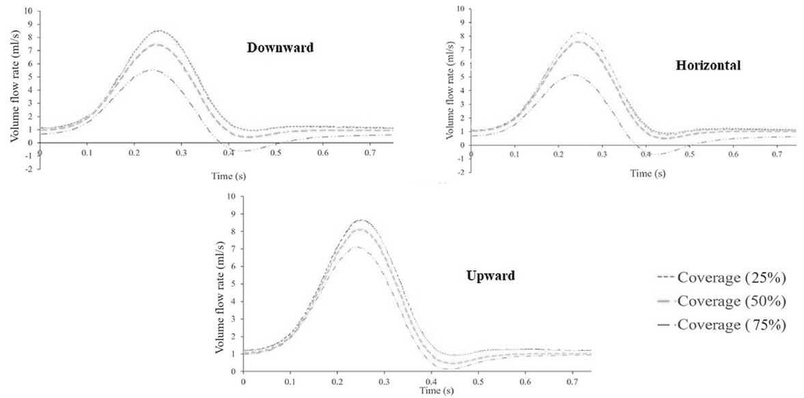
Figure 4: Instantaneous volume flow rate of the left renal artery during a cardiac cycle, the renal arteries with downward, horizontal and upward orientation
The renal arteries oriented downward had the highest blood perfusion, while the arteries oriented upward had the lowest, concerning the mild coverage (~25 %). In contrast, the cumulative flow rate in the upward renal arteries had the least reduction in blood perfusion with respect to 75 % coverage during a cardiac cycle for the serious coverage (~50 %). In relation to the TAWSS or RRT on the vessel wall, the renal artery with a downward orientation exhibited a less unfavourable WSS distribution for the mild partial coverage (~25 %). When mild partial coverage developed, the downward renal artery may be at lower risk of thrombosis. On the caudal and cranial walls of all three types of renal arteries, however, unfavorable WSS distribution progressively increased in tandem with the worsening of coverage (~50 %).

4. Conclusions
For mild renal coverage following EVAR, renal arteries oriented downward may have the advantage of lowering the risk of renal occlusion. The main concern for all types of renal arteries remains the high risk of renal complications due to highly disturbed wall shear distribution, which would increase significantly if serious renal coverage appeared regardless of renal orientation. Since renal arteries oriented horizontally continue to suffer from more unfavourable wall shear distribution than renal arteries with upward or downward orientation, it may be necessary to accept longer follow-up even in cases of mild partial renal coverage.

- References
Y. Cho, K. Kensey, 1991, Effects of the non-Newtonian viscosity of blood on ﬂows in a diseased arterial vessel. Part 1: steady ﬂows. Biorheology, 28, 241–62
L. Edwards, D. Dhanpat, D. Chakrabarti, 2018, Hydrodynamics of three phase flow in upstream pipes, Cogent Engineering, 5, 1433983
H. Himburg, D. Grzybowski, A. Hazel, J. LaMack, X. Li, M. Friedman, 2004, Spatial comparison between wall shear stress measures and porcine arterial endothelial permeability, Am J Physiol Heart Circ Physiol, 286, H1916–22
J. Jun Wen, X. Liu, J. Lei, J. Wang, X. Chen, T. Zheng, D. Yuan, 2023, Hemodynamics in renal arteries with partial coverage after endovascular aneurysm repair affected by renal orientations. Medicine in Novel Technology and Devices, 18, 100224
K. Kerst, L. de Souza, A. Bartz, A. Seidel-Morgenstern, G. Janiga, 2015, CFD-DEM simulation of a fluidized bed crystallization reactor, CACE, 37, 263-268
D. Ku, D. Giddens, C. Zarins, S. Glagov, 1985, Pulsatile ﬂow and atherosclerosis in the human carotid bifurcation. Positive correlation between plaque location and low oscillating shear stress, Arteriosclerosis, 5, 293
S. Lee, L. Antiga, D. Steinman, 2009, Correlations among indicators of disturbed ﬂow at the normal carotid bifurcation, J Biomech Eng, 131, 61013
M. Liu, A. Sun, X. Deng, 2018, Hemodynamic effect of obstruction to renal arteries caused by stent grafts in patients with abdominal aortic aneurysms, J Mech Med Biol, 18, 1–14
E. Martínez, R. Jaimes, J. Gomez, R. Maciel Filho, 2012, CFD simulation of three-dimensional multiphase flow in a rotating packed bed, CACE, 30, 1158-1162
S. Paravastu, R. Jayarajasingam, R. Cottam, S. Palfreyman, J. Michaels, S. Thomas, 2014, Endovascular repair of abdominal aortic aneurysm, Cochrane Database Syst Rev, CD004178
J. Parodi, J. Palmaz, H. Barone, 1991, Transfemoral intraluminal graft implantation for abdominal aortic aneurysms, Ann Vasc Surg, 5, 491–9
L. van de Velde, E. Donselaar, E. Groot Jebbink, J. Boersen, G. Lajoinie, J. de Vries, C. Zeebregts, M. Versluis, M. Reijnen, 2018, Partial renal coverage in endovascular aneurysm repair causes unfavorable renal ﬂow patterns in an infrarenal aneurysm model, J Vasc Surg, 67, 1585–94

